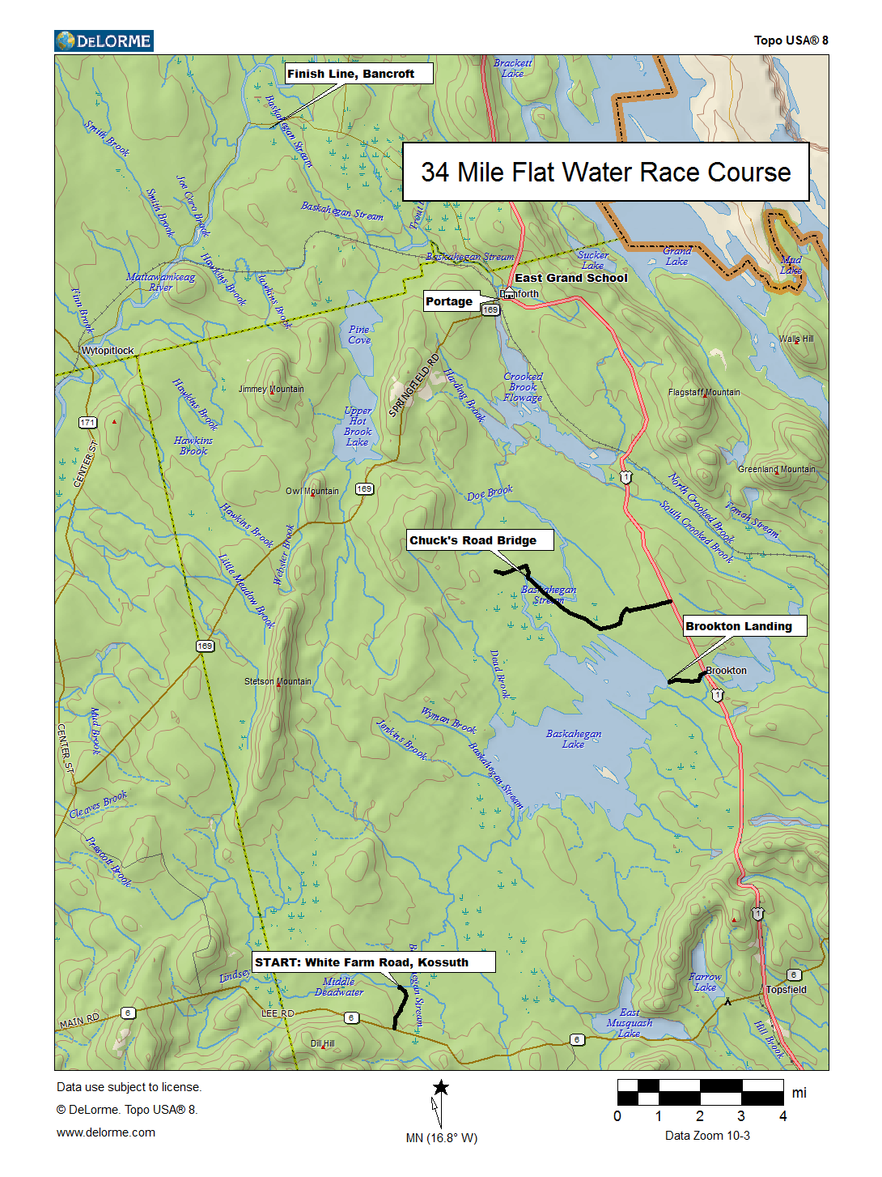
34 Mile Baskahegan Stream Race Course Notes

This race will run in conjunction with the adventure race.

Meeting Place: Check in is 7:00 AM at the East Grand School. After checking in and a short debrief, we load up (transportation provided for you and your boat) and head to the starting line on the White Farm Road in Kossuth. The finish line is 8 miles from the school and a shuttle service is provided to bring you and your boat back to the school.

The Course: From the White Farm Road, the river meanders for 7.75 miles to the Baskahegan Lake. The river is passable at low water but some wading is necessary. This should not be a problem in middle May. It is 4.25 miles across Baskahegan Lake to the outlet where there is some remains of a washed-out dam. Stay in the middle of the main chute (easy quick water) and you will avoid a spike that is on the far right next to the shore. It is 9.25 miles of stream to Crooked Brook Flowage. On the first stretch you will paddle through a Bog (watch for moose!) with the last four miles being a little stronger with a couple of spots that may be class I. Next paddle 3.5 miles on Crooked Brook Flowage north towards the dam in Danforth. CAUTION Portage left around the lowhead dam in Danforth (marked). Below Danforth the Baskahegan Stream is mostly flat water for 8.5 miles with a couple of quick water sections in the middle and one class I rapid in front of a cabin and 1/3 mile before the finish line. The finish line is the 3rd cabin on the right and just upstream of the 2000 Road Bridge. Be sure to take out here. CAUTION Below the bridge it turns into class III-IV with ledge drops. We will transport you back to the East Grand School for lunch and awards.

Cutoff Time: When arriving at the Lowhead dam after 2PM, we ask you to end your race there or make arrangements to be picked up at the finish line. Call Dave Conley to make arrangements to be picked up late at the finish line, cell 551-8729

Note: In the event wind is forecasted, the race course will be modified. You can call the day before the race to confirm starting location. call Dave Conley 551-8729

Safety Boats on Baskahegan Lake Buck Plummer 746-7982, Albert Trembly 805-8181, Jerry Downs 538-5380, Dan Daggett 319-2561, Mark McKinnon 214-7834

Access Points:
There really is no way to scout the stream as it is a remote wilderness section. Chuck's Road Bridge and a camp in Bancroft in front of the class I rapid will give you vantage points but scouting these points are not really necessary.

Outhouse: In Danforth at the boat landing on the left 500 yards before the portage.

Portage Left at the Lowhead dam (water and snacks on the portage trail)

Early Exit Points:
Landing in Brookton (Call Buck Plummer)
In Town Danforth (landing or lowhead dam)

Use your cell Phone to call a safety/sweep person if you need assistance along the way

